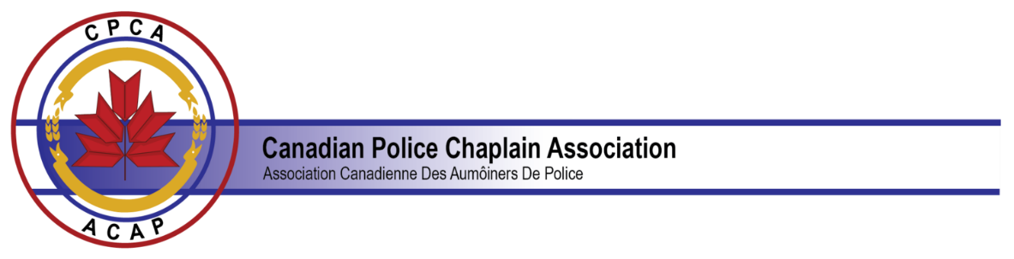

President's Letter
December 4, 2020

Greetings to All!
Have you ever seen a snow globe? My children loved to turn ours upside down and topsy-turvy to watch the flurry of snow that would obscure the miniature residents from sight until the snowflakes would settle and the world turned back to rights again. One of my kids was not content to give the globe a gentle shake but would agitate it mercilessly until it seemed that there was no end to the blizzard. For many of us, our world, both personal and professional, has taken on the appearance of a snow globe. Everything is unsettled and it is hard to see how there will be an end to the disruptions of 2020. We seem to have lost control over our lives and for some, the chaos threatens to overwhelm.
"Defund the Police," and "Black Lives Matter" have become familiar mantras in the media. Calls to end systemic racism and police brutality have put police services on the defensive and have raised the stress levels from the lowest constable to the highest white shirt. Drug overdoses, gun calls, and mental health wellness checks are on the rise. It seems everyone is more on edge these days! This is the world in which we as police chaplains find ourselves.
The CPCA has also had some shaking up this year. Our Annual Training Seminar scheduled for Niagara Falls in October was first put on hold and then postponed indefinitely when travel within Canada became impossible. Who could have anticipated the fallout from COVID-19? We transitioned to Zoom meetings, and we arranged to hold our Annual General Meeting virtually, allowing for chaplains from across the country to participate. Thank you to each one who participated!
We want to transform the CPCA into an organization that is increasingly diverse and inclusive. This work is slow because there are so many ways in which our personal bias blinds us to how others perceive things. However, as a CPCA Leadership Team, we are working through our documents and practices to ensure that everyone can feel valued as a part of our Association. There are more conversations to have, and we will be consulting our members and other experts on the best ways to move forward. We need your patience when our best does not meet your expectations, your challenges to the status quo that inspire us to improve, and your wisdom in charting the course ahead.
2020 was an election year for the CPCA Executive. As a result, there is a new Leadership Team in place to represent and serve you. Our names and photos are on the back page of the Newsletter and on the CPCA website. However, if we are to succeed as an Association each member must contribute in whatever ways they can. We are all a valuable part of the team!
As a Leadership Team we are excited as we anticipate changes that will make the CPCA a more influential voice in promoting police chaplaincy programs and high-quality training throughout Canada. We are committed to providing online training, which will be available at a reasonable cost for all CPCA chaplains which will be delivered by CPCA certified instructors. Our website will be taking on a more professional look in the New Year and we will engage in new, more effective ways to communicate with our membership and police services as well. Finally, we now have Constitutional changes in place to allow for the formation of Regional Chapters such as the Police Chaplains Association of Ontario. By adding regional groups, we hope to build ties between what is happening locally, regionally, and nationally.
I think the most important goal we have for 2021, however, is to strengthen the connections we have between us as police chaplains. Chaplaincy can be a lonely endeavour. Often, we are separated by distance and busy schedules. Recently I listened to a podcast by Dr. Jody Carrington speaking to police and their family members. She identifies one of the greatest challenges today as being disconnected, and she calls for us to "do the holy work of connection." As a guiding principle for her service to others, she quotes Ram Dass: "We are all just here walking each other home."
As we head into 2021, the CPCA Leadership Team is committed to sharing the journey with you. We need each other and each one of us brings that unique something to the table that will make us less without you!
Stay safe and be well! Be kind to yourself and each other! And, regardless of how fierce the storm, may we know the companionship that grows as we strive to all just walk each other home.

Chaplain Marion Jamer
President
Canadian Police Chaplain Association

